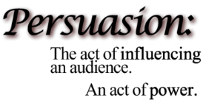
Argumentative Essay Rubric:
Directions: Using the information you have found, I want you to answer the question in a persuasive essay. “How long does it have to be?” My answer to that question is this: the grade I give you is not based on how “long” your essay is, it’s based on how your essay is developed. If you put an effort to thoroughly explain your stance, then you should do fine. If you put forth little effort, you will receive a little grade.

Requirements/Rubric: (You MUST turn in the outline with the final)

- Essay must be typed and in MLA format ………………………………………………………………………………………._______/20
  - Use 12 point Times New Roman throughout (including title)
  - Use a proper heading
  - Center your title ONLY (Title must be properly formatted as well)
  - Double Spaced
  - Indent paragraphs (hit the “tab” button once)
  - Include proper page enumeration (your last name and page # in top right corner of each page)
  - Check that all quotes have lead-ins and are fully explained and have citation
- Ideas…………………………………………………………………………………………………………………………………………….._______/25
  - Thesis is a clear and opinionated stance on your topic
  - topic is clearly identified in the introduction
  - Use evidence to support your claim (in other words, USE QUOTES)
  - use rhetorical questions
  - A counterargument is presented and with a rebuttal
  - The conclusion has a “call to action”
- Organization…………………………………………………………………………………………………………………………………_______/20
  - Have a clear introduction and conclusion paragraph
  - Each paragraph is focused on one claim and piece of evidence
  - Use ONE quote from your article with a proper lead-in and citation as evidence
  - Transition between paragraphs using transition words (In addition, finally, etc.)
- Language………………………………………………………………………………………………………………………………………_______/20
  - Get rid of the verb “get”
  - Get rid of all contractions
  - Reduce the number of personal pronouns like “I” or “you”
  - If a number is less than 10, spell out the number. If it is over 10, then write the number
- Conventions (a.k.a grammar) ………………………………………………………………………………………………………_______/15
  - Check for punctuation, spelling capitalization
  - Eliminate vague pronoun references

HOW TO DO IN-TEXT CITATIONS: (IN-TEXT CITATIONS ARE REQUIRED FOR EACH QUOTE FROM A TEXT THAT YOU PUT IN YOUR ESSAY)

An in-text citation for a text has FOUR things:

- A “lead-in” to the quotation
  - This is the part that tells the reader why you are introducing a quote
  - A LEAD-IN IS ALWAYS NECESSARY
  - Example lead-ins:
    - John demonstrates __(IDEA)__ when he says, ←that is a lead in, quote comes after this
    - The idea of _________ is evident when the speakers says,
    - Carlos admits to his error when he says,
    - The character makes her intentions clear as day: you can use a colon too.

- The quote itself
  - You must always have quotations “” ←these things around the direct quote (this means you copy it EXACTLY as you see it in the text)

- The in-text citation
  - This part is the most technical. A citation shows your reader exactly where you found the quote.
  - The punctuation is very specific
  - USUALLY IT IS THE AUTHOR’S LAST NAME AND THE PAGE NUMBER WHERE YOU FOUND THE QUOTE. HOWEVER, if there is no author, then you will use the title of the article in the in-text citation.

Ex: Chuck Liddell concludes his idea when he says, "Of everything that happened, That's all I remember" (O’Connor 46). realize that the period is always at the end

Ex: Chuck Schumer supports the new dress code in schools when he says, “dress codes lead to limited student creativity” (“The New Look of Schools”).

- An Explanation of The Quote
  - You must explain why the quote is important and what the quote shows.
  - For example, use this sentence starter, “This quote shows…” use this sentence starter

HOOK WRITING OPTIONS
Do not use “you” or “I”.
A “hook” is the first sentence that grabs the attention of the reader with something interesting, shocking, and engaging.
Below are different options that you can use with examples.
- Start with a rhetorical question.
  - Is social media a benefit to its users or a curse?
  - Your example: ______________________________________________________________________________________________________________________________________________________________________

- Describe a shocking scenario that paints a possible worst case scenario.
  - Social media may one day control the everyday lives of its users
  - Your example: ______________________________________________________________________________________________________________________________________________________________________

- Us an Imagine… statement.
  - Imagine a society that does not read literature from its own history.
  - Your example:
______________________________________________________________________________________________________________________________________________________________________
- Use a quote from a song/famous person
  - As Edmund Burke once stated, “All it takes for evil to triumph is for good men to be silent.”
  - Your example:
___________________________________________________________________________________
___________________________________________________________________________________
Now look at the HOOKS you’ve written. Choose one to use as the first sentence of your essay.
____ ____

EDITING CHECKLIST
Be sure to check each of the following: | Yes |  | No
1. REDUCE YOUR USE OF these pronouns: I, we, me, us, my, our, mine, ours, you, your, and yours. The only exception is when you are quoting something directly from the text.
3. Spell correctly, especially their, there, and they’re and your and
you’re.
4. Get rid of filler words like well, basically, “If you ask me,” etc.
5. Write out your words. You’re not texting.
6. Do not use contractions in formal writing unless it is a direct quote.
7. MLA Format
8. Indent to show new paragraphs.
9. DO NOT SKIP ADDITIONAL LINES BETWEEN PARAGRAPHS.
10. Quotations are written with an introductory phrase, citation, explanation, and are properly punctuated.

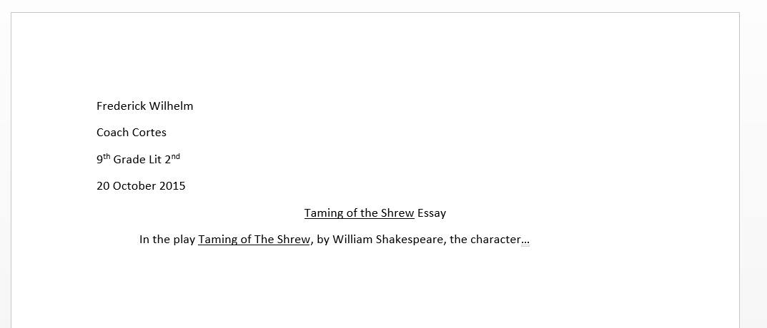
MAKE YOUR ESSAY LOOK LIKE THIS

